Open Educational Resources Training Platform (OERTP)
Software Quality Assurance Plan
Release 1
Version 2

Raj Bharath Adamaram Seshadri
Intern at United Nations, Educational, Scientific and Cultural Organization (UNESCO)

Contents
1. Introduction 4
1.1 Purpose 4
1.2 Scope 4
1.3 Reference Documents 4
2. Management 4
2.1 Management Organization 4
2.2 Project Manager 4
2.3 Quality Analyst 5
2.4 Software Development Process 5
3. Software Development Process – Quality Assurance Plan 6
3.1 Planning Phase 7
3.2 Intermediate Phase 7
3.3 Development Phase 8
4. Quality Assurance Tasks 8
5. Software Assurance Estimated Resources 10
6. Documentation 10
7. Standards, practices, conventions and metrics 13
7.1 Software Quality Program 13
7.3 Standard Metrics 13
7.4 Reviews 14
7.5 Inspection Week for Planning Phase 17
8. Testing 19
9. Problem Reporting and Corrective Action 19
10. Risk Analysis for Quality Assurance 20
Appendix A: Change log history 22

Introduction

Purpose

The purpose of this Software Quality Assurance Plan (SQAP) is to establish the goals, processes, and responsibilities required to implement effective quality assurance functions for the Open Educational Resources Training Platform (OERTP) using Drupal 7 technologies.

The SQAP provides the framework necessary to ensure a consistent approach to software quality assurance throughout the project life cycle. It defines the approach that will be used by Software Quality personnel to monitor and assess software development processes and products to provide objective insight into the quality of the software. The systematic monitoring of OERTP products, processes, and services will be evaluated to ensure they meet requirements and comply with United Nations, Educational, Scientific and Cultural Organization (UNESCO) policies, standards, and procedures.

1.2 Scope

This plan covers SQA activities throughout all software development phases of the OERTP.

1.3 Reference Documents

The following documents were used or referenced in the development of this plan:

- OERTP Project Management Plan

Management

This section describes the management organizational structure, its roles and responsibilities, and the software quality tasks to be performed.

2.1 Management Organization

OERTP efforts are supported by UNESCO. Relevant entities/roles that are of interest and applicable to this SQAP and the software assurance effort are described at the following subsections.

2.2 Project Manager

The OERTP project manager (PM) is responsible for management of project objectives and the project plan. The project manager is specifically responsible for the success of the OERTP project, including but not limited to cost, schedule, and quality.

2.3 Quality Analyst

The Quality Analyst (QA) is responsible for supporting the PM in the coordination of the definition and implementation of a SQAP for the project.

The QA provides project management with visibility into the processes being used by the software development teams and the quality of the products being built. The quality maintains a level of independence from the project and the software developers. Risk and problem escalation begins at the project level, and extends to the PM and the QA.

Responsibilities include, but are not limited to:

- Develop and maintain the project SQAP

- Generate and maintain a schedule of software quality assurance activities

- Conduct process and product assessments, as described within this plan, using objective criteria

- Identify and document noncompliance and problems for all software assurance related activities

- Communicate results from assessments with relevant stakeholders

- Ensure resolution of noncompliance and escalate any issues that cannot be resolved within the project

- Identify lessons learned that could improve processes for future products

- Develop and maintain metrics

2.4 Software Development Process

In this project an iterative process model is used to fulfill the goals of the project described in the project plan.

According to the project plan, the development is divided into two major phases. In Fig. 1 the process model is schematically pictured.

First there is a planning phase, where the requirements are set and categorized by their priority according to the customer. Then the system's basic architecture is developed.

In the second phase, the development of the concrete system is started. The system is developed in small cycles. At first only the core features of the system are implemented. In the iterations, more sophisticated features are added depending on the priorities the customer declared in the requirements specification.

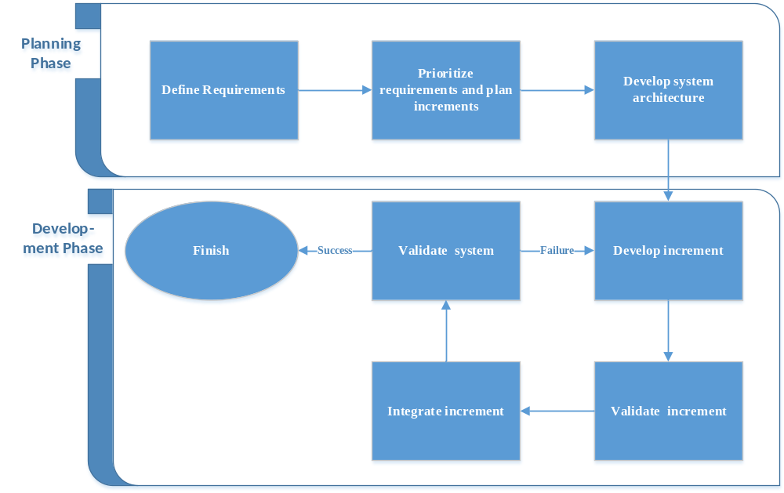

Figure 1: Schematic process model for iterative development used in this project

Software Development Process – Quality Assurance Plan

For the Quality Assurance Plan, the planning phase is again separated into two phases to get a more strict separation between the “paperwork” and the executable system. Fig. 2 shows the new schematic process model that is used.

In this project we use two categories of quality assurance techniques. At first there are constructive quality assurance techniques. They are called constructive because their intent is to avoid mistakes made by the developers. The idea is, if the techniques are used correctly, there should be less severe defects in the upcoming system, because less conceptual defects are present in the system. The other category insists of analytic quality assurance techniques. The intent of these techniques is to reveal already existent defects in a program. There are kinds of defects that can be revealed by both or one of them so both strategies are important.

There exist several methods for each technique that can be applied in specific phases of the software development process.
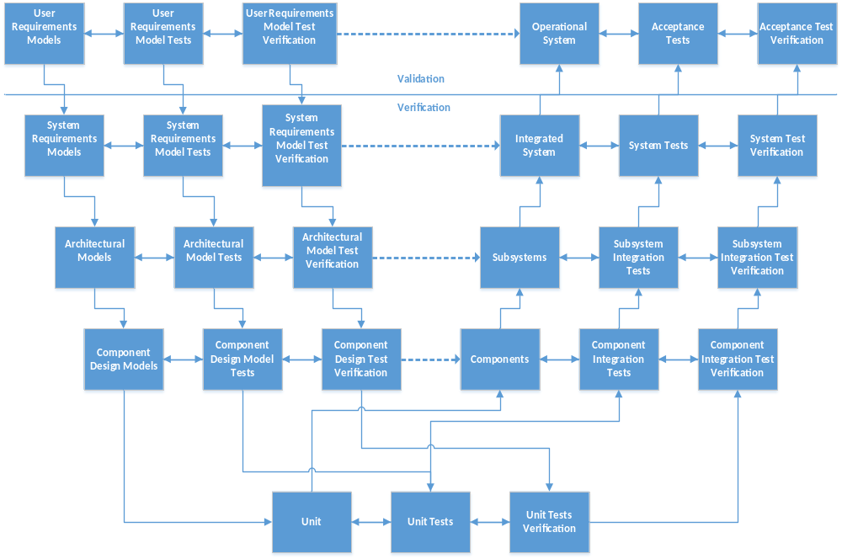
Figure 2: Schematic process using V Model for iterative development used for quality assurance in OERTP project

3.1 Planning Phase

In the first phase, all requirements are in the focus of the development team. This phase is important to be able to plan the increments and to be able to develop a flexible and well-suited system architecture.
Constructive quality assurance techniques are a good choice for this phase. Therefore formal inspections are used to check the requirements.

3.2 Intermediate Phase

The development of the system architecture can be seen as an intermediate step between planning and development, because it logically belongs to both phases. It belongs to the planning phase because all requirements have to be focused that the system’s architecture is flexible enough to be able to implement all requirements in an efficient way. It belongs to the development phase because the basic components of the architecture can already be developed. There could be general components in the system, e.g. non-functional components that can already be implemented.
In this phase, constructive and analytic quality assurance techniques are used.

3.3 Development Phase
In the development phase, the defined iteration cycles are performed. In an iteration cycle, only parts of the requirements are focused. Every iteration cycle has its own set of requirements that have to be fulfilled. If an increment is developed, it has to be integrated into the base system.
In this phase, the focus is put on analytic quality assurance techniques.

Quality Assurance Tasks
This section summarizes the quality planning, control and steering tasks to be performed during the development of software. These tasks are selected based on the project plan, planned deliverables, and identified reviews. The planned tasks include, but are not limit to:

- Quality planning

- Perform SQAP for the project
The current SQAP has been specified according to OSP project plan and based on the IEEE STD 730-2002, IEEE Standard for Software Quality Assurance Plans

- Review and update SQAP
At the beginning of each phase, QA should review the SQAP and update it according to the project progress and corrective actions.

- Quality control

- Product assessment:
The product assessment start with the identification of the minimum documentation required for the current project, approval mechanism and approval criteria (See section Documentation). It also includes reviews of the major work product (See section Reviews) and testing (See section Testing).

- Process assessment
The process assessments will be covered project planning, project monitoring and control, reviews, requirements specification and management, architectural design, coding, test design and execution, and risk management

- Quality steering

- Software problem reporting and corrective actions
- Lessons learned
Table 1 provides a summary of software quality assurance tasks during the project phases. At first the SQAP is created and maintained over the whole project. For quality steering, the project progress is tracked. If problems seem to come up, the PM is informed.

Quality Tasks | Planning Phase | Intermediate Phase | Development Phase
Quality Planning | Create SQAP for current  and next phase, create  templates and  guidelines | Review SQAP for  current phase, extend  SQAP for next phase | Review SQAP for  current phase
Quality Control | Assess process adherence and see Table 2 | Assess process adherence and see Table 3 | Assess process adherence and see Table 4
Quality Steering | Report problems and keep track of the project | Report problems and keep track of the project | Report problems and keep track of the project
Table 1. Software Quality Assurance Tasks Matrix

Quality Control Tasks | Planning Phase
Documentation | Assess requirements specification documents
Reviews | Perform a formal review of the requirements specification, validate the database schema against the requirements
Testing | ---
Table 2. Software Quality Control Tasks for Planning Phase

Quality Control Tasks | Planning Phase
Documentation | Assess the software architecture
Reviews | Perform a structured walkthrough for the use cases that were identified in  the requirements specification
Testing | Develop a test environment for the software
Table 3. Software Quality Control Tasks for Intermediate Phase

Quality Control Tasks | Planning Phase
Documentation | See SPMP documentation
Reviews | See SPMP documentation
Testing | See SPMP documentation
Table 4. Software Quality Control Tasks for Development Phase

Software Assurance Estimated Resources

The staffing resource levels provided in the table below represent what the Quality Assurance has currently planned, where “PD” is Person in days.

Task | Support personnel | Planning Phase (Efforts in PD) | Intermediate Phase (Efforts in PD) | Development Phase (Efforts in PD) | Total (Efforts in PD)
Quality Planning | Quality Analyst | 5 | 2 | 2 | 9
Quality Control | Quality Analyst | 5 | 4 | 10 | 19
Quality Control | Project Manager | 2 | 2 | 2 | 6
Quality Control | Team Leader | 1 | 3 | 1 | 5
Quality Control | Senior Management | 0 | 2 | 3 | 5
Quality Control | System Analyst | 3 | 2 | 1 | 6
Quality Steering | Quality Analyst | 3 | 3 | 3 | 9
Table 5. Effort for Quality Assurance

Documentation

This section identifies the minimum documentation governing the requirements, developments, verification and validation of software that falls within the scope of this SQAP. Each document will be assessed and approved by the following mechanism:
Approval mechanism

Input: Any project document

Input criteria: The document is completed and includes no obviously known defects.

Participants/ responsibilities:

Participant | Responsibilities
Project Manager | - To initiate the process and to provide the document  - To review the document  - To plan and supervise corrective actions
Quality Analyst | - To coordinate the process  - To review the document  - To suggest and monitor corrective actions  - To assure the completion of the corrective actions
Others | - To review the document

Procedure:
- According to the project plan, the PM submits the document to approval.

- The PM and the QA and other possible reviewers compare the document according to the corresponding checklist.

- If there are defects found in the document, corrective actions have to be planned. The QA should assure the completion of the corrective actions. A defect can either be major or minor, depending on the decision the reviewers make.
- If there were major defects in the document they have to be fixed and another review has to be done with the corrected document. The document cannot be accepted.

- In the case of minor defects the document can be accepted under the condition that the defects are to be fixed. No additional review of the document is needed.

- The document is accepted and can be submitted to the persons that are interested in this document.

Associated documentation:
- Approval resolution template
- Checklist according to the document

Exit criteria: The document is approved by the review team.

Exit: Approval resolution, Approved document.

The following table identifies the minimum documentation required for the project, the approval criteria and the responsible persons.
R = Responsible; A= Approve

Table 6. Approval Criteria
Deliverables | Approval Criteria |  |  |  |  |  |  |  |  | Responsible Designations
Deliverables | Correctness | Completeness | Consistency | Non-ambiguity | Prioritized | Modifiable | Traceable | Verifiable |  | Project Manager | Quality Analyst | Business Analyst | Team Leader | Senior Management | Client (UNESCO)
Software Project Management plan | ✓ | ✓ | ✓ | ✓ |  |  |  |  |  | R |  |  |  | A
Software  Quality  Assurance  Plan | ✓ | ✓ | ✓ | ✓ |  |  |  |  |  | R | R |  |  | A
Software Configuration Management Plan | ✓ | ✓ | ✓ | ✓ |  |  |  |  |  | R |  | R |  | A
Software Requirements  Specification Plan | ✓ | ✓ | ✓ | ✓ | ✓ | ✓ | ✓ | ✓ |  | R |  |  | R | A
Software Design Descriptions Plan | ✓ | ✓ | ✓ | ✓ | ✓ | ✓ | ✓ | ✓ |  | R |  |  | R | A
Database  Schema | ✓ | ✓ | ✓ | ✓ |  |  | ✓ | ✓ |  | R |  |  | R | A
Architectural  Design | ✓ | ✓ | ✓ | ✓ |  | ✓ | ✓ |  |  | R |  |  | R | A
Component  Design | ✓ | ✓ | ✓ | ✓ |  | ✓ | ✓ |  |  | R |  |  | R | A
Test Reports  and Artifacts | ✓ | ✓ | ✓ | ✓ |  | ✓ | ✓ |  |  | R | R
Software  User’s Guide | ✓ | ✓ | ✓ | ✓ |  | ✓ | ✓ |  |  | R |  | R |  | A | A

Standards, practices, conventions and metrics

This section highlights the standards, practices, quality requirements, and metrics to be applied to ensure a successful software quality program.

7.1 Software Quality Program

The specific procedures, work instructions, checklist, and templates used by quality assurance, will be published at the issue tracker of GitLab. For further information please refer. Software Configuration Management Plan (SQMP). They include, but are not limit to:
- Procedures/Guidelines: Inspection procedure, Perspective Based Reading, Architectural design review guidelines, Component design review guidelines

- Work instructions: Testing planning, Design of test cases

- Checklist: Checklist according to the document

- Templates: Approval resolution template, Inspection reports, Test plan template, Test results template, Problem reports template, Lessons learned template, Assessment results and corrective actions status

7.3 Standard Metrics

The following standard metrics are the minimum planned metrics that will be collected, reported, and maintained in the area of software quality assurance:

- Effort expended for all phases(Planned vs. Actual)

- Number of SQ assessments, e.g. reviews, test activities(Planned vs. Actual)

- Number of SQ assessment findings or non-compliances (Open vs. Closed)

Additional Project metrics may also be collected, reported, and maintained. Sample metrics include:
- Number of approved documents (Planned vs. Actual)

- Number of open vs. closed software problem reports (reported by customer)

- Number of open vs. closed defects (reported by team)

- Number of open vs. closed change request

- Number of requirement changes (related to change requests, but more severe)

7.4 Reviews
During the project several major inspections are planned: software requirement specification inspection architectural design review and component design review. The process for planned inspections is described in the following table:
Inspection process
Input: Project artifact
Input criteria: The PM submits the project artifact to inspection.
Participants/ responsibilities:
Participant | Responsibilities
Project Manager | - To initiate the process and to provide the product artifact  - To provide the required resources to conduct the process  - To participate in the inspection  - To plan and supervise corrective actions
Quality Analyst | - To coordinate the process  - To review the document  - To suggest and monitor corrective actions  - To assure the completion of the corrective actions
Inspectors (SM and TL) | - To review the document  - To prepare the inspection  - To participate in the inspection

Procedure:
1. Organization
a. According to the project plan, the PM submits the artifact to inspect.
b. The QA organizes the inspection and distributes the artifact, the reading guidelines, checklists and the corresponding inspection report to each inspector according to the inspection plan.
2. Preparation
a. Each inspector reviews the artifact individually according to the reading guidelines, checklists and fulfills the inspection report.
b. Each inspector sends the inspection report to the QA.
3. Inspection meeting
a. The inspectors, the PM and the QA discuss the detected defects. The QA creates the final inspection report.
b. QA includes the defects in issue tracker.
4. Rework
a. The PM and the QA discuss and agree corrective actions.
b. The PM assigns the corrective actions and provides the necessary resources to fix the defects.
c. The QA assure the completion of the corrective actions.
Associated documentation:
- Reading Guidelines
- Checklists (Suitable for the document)
- Inspection report

Exit criteria: The QA and the PM approve the rework of the artifact
Exit: Reworked Artifact, Inspection report.

7.5 Inspection Week for Planning Phase

7th January 2014 to 13th Jan 2014

Artifacts to check:

- Requirements specification
- Software Architecture
- Database Schema

Requirement Specification
Artifact | Requirement specification
Purpose | To check the correctness of the requirement specification from the point of view of different involved roles.
Participants | Team Leader  Project Manager  Quality Analyst  Business Analyst  Other reviewers
Estimated date/ duration | Preparation: 09.09.08 (ca 2h, afternoon)  Inspection: 10.09.08 (ca. 1,5h) (morning, 9 – 11) (only use cases)
Inputs | Requirement specification
Technique | Formal inspection using Focused Checklists
Procedure | Reading guidelines  Focused Checklist for each role  Inspection
Output | Inspection report
Table 7. Requirements specification

Software Architecture
Artifact | Software architecture
Purpose | To check the correctness and the feasibility of the architecture design based on the requirements specification.
Participants | Team Leader  Project Manager  Quality Analyst  Other reviewers
Estimated date/ duration | Preparation: 09.09.08 (ca 2h, afternoon)  Inspection: 10.09.08 (ca. 1,5h) (morning, 9 – 11) (only use cases)
Inputs | Software requirement specification  Architectural Design
Technique | Expert Review
Procedure | Inspection
Output | Inspection report
Table 8. Software Architecture

Database Schema
Artifact | Database Schema
Purpose | To check the correctness of the database scheme according to the requirements specification.
Participants | Team Leader  Quality Analyst  Project Manager  Other Reviewers
Estimated date/ duration | Preparation: 09.09.08 (ca 2h, afternoon)  Inspection: 10.09.08 (ca. 1,5h) (morning, 9 – 11) (only use cases)
Inputs | Informal review  The author prepares the topic and presents it to the team. They try to reveal defects in the meeting.
Technique | Expert Review
Procedure | Inspection
Output | Inspection report
Table 9. Database Schema

Testing

- QA is responsible to lead and perform the test plan, including unit testing, integration testing (verification) and acceptance testing (validation). QA will monitor testing efforts to assure that test schedules are adhered to and maintained to reflect an accurate progression of the testing activities.

- They will assure that tests are conducted using approved test procedures and appropriate test tools, and that test anomalies are identified, documented, addressed, and tracked to closure.

- In addition, QA will assure that assumptions, constraints, and test results are accurately recorded to substantiate the requirements verification/validation status.

- QA personnel will review post-test execution related artifacts including test reports, test results, problem reports, updated requirements verification matrices, etc.

Problem Reporting and Corrective Action

- The QA generates tracks, and trends assessment findings and observations, available at the developer’s site in the section Quality Assurance. See section problem reports and corrective actions.

- Each problem report will be sent to the PM directly. The QA and the PM agree and plan the definitive corrective actions. The QA is responsible for supervising the completion of the corrective actions.

- During the project, the QA informs weekly the assessments results and the corrective actions status to the project manager.

Risk Analysis for Quality Assurance

The following bale shows the Risk Analysis done to ensure Quality Assurance is done properly for the OERTP project.
Risk | Probability | Risk Type | Contingencies / Mitigation Approach
Unable to acquire the necessary number of skilled personnel as the components become ready to test. | 30% | Personnel  Schedule | Resources for components will be split between the existing resources.  Schedule must be adjusted accordingly.
Unable to acquire some of the necessary hardware and software required for integration and system testing | 25% | Equipment | Utilize existing acquired hardware.  Split test execution into morning and evening shifts such that testing can occur for multiple teams in the same day using the limited hardware. This requires support of the development during both shifts.
Third party services utilized in the system become unavailable during testing | 5% | Third party | Setup a communication channel to 3rd party to report and handle issues when they occur.  Use the communication channel above to stay aware of planned outages and maintenance to help schedule test execution.
Components are not delivered on time | 25% | Schedule | Integration testing with those components must be delayed until the component is delivered  Overall integration test approach may be modified to do an appropriate amount of bottom-up as well as top-down or sandwich integration.  Schedule must be adjusted accordingly.
Turnover | 5% | Personnel | Testers will work in pairs on components. If a single member of the team decides to leave, a secondary testing with the knowledge of the component will still be able to train a new tester or finish the work.  Schedule must be adjusted accordingly.
Functionality | 50 % | Design and Coding | Check Logic and take necessary steps to notice errors of concurrency.  Computation: Check code and coding standards.
Reliability | 20 % | Design and Coding | Interfacing and Data handling: Need to be addressed using SQL profiler and check for data concurrency issues.
Usability and Efficiency | 20 % | Design and Coding | Input data problem and system speed test to check the usability of the product.
Maintainability | 5 % | Design and Coding | Check if the modules are compatible during future up gradation process.  Check on core modules for not being altered thus ensuring flexibility of the system.
Table 10. Risk Analysis

Appendix A: Change log history
Please refer to Configuration Manager as the change history is regularly updated in “GitLab” Configuration Manager.

